
- Vocabulary -
ESCOLA SECUNDÁRIA EÇA DE QUEIRÓS
School Year 2009/ 2010
English
Name: Pedro Aurélio Class: S - 13

Teacher: Teresa Rafael

Teacher: Teresa Rafael
“The World of Work”
- Compare the job market today to the job market in the past. Choose characteristics from the box below and define both work realities.
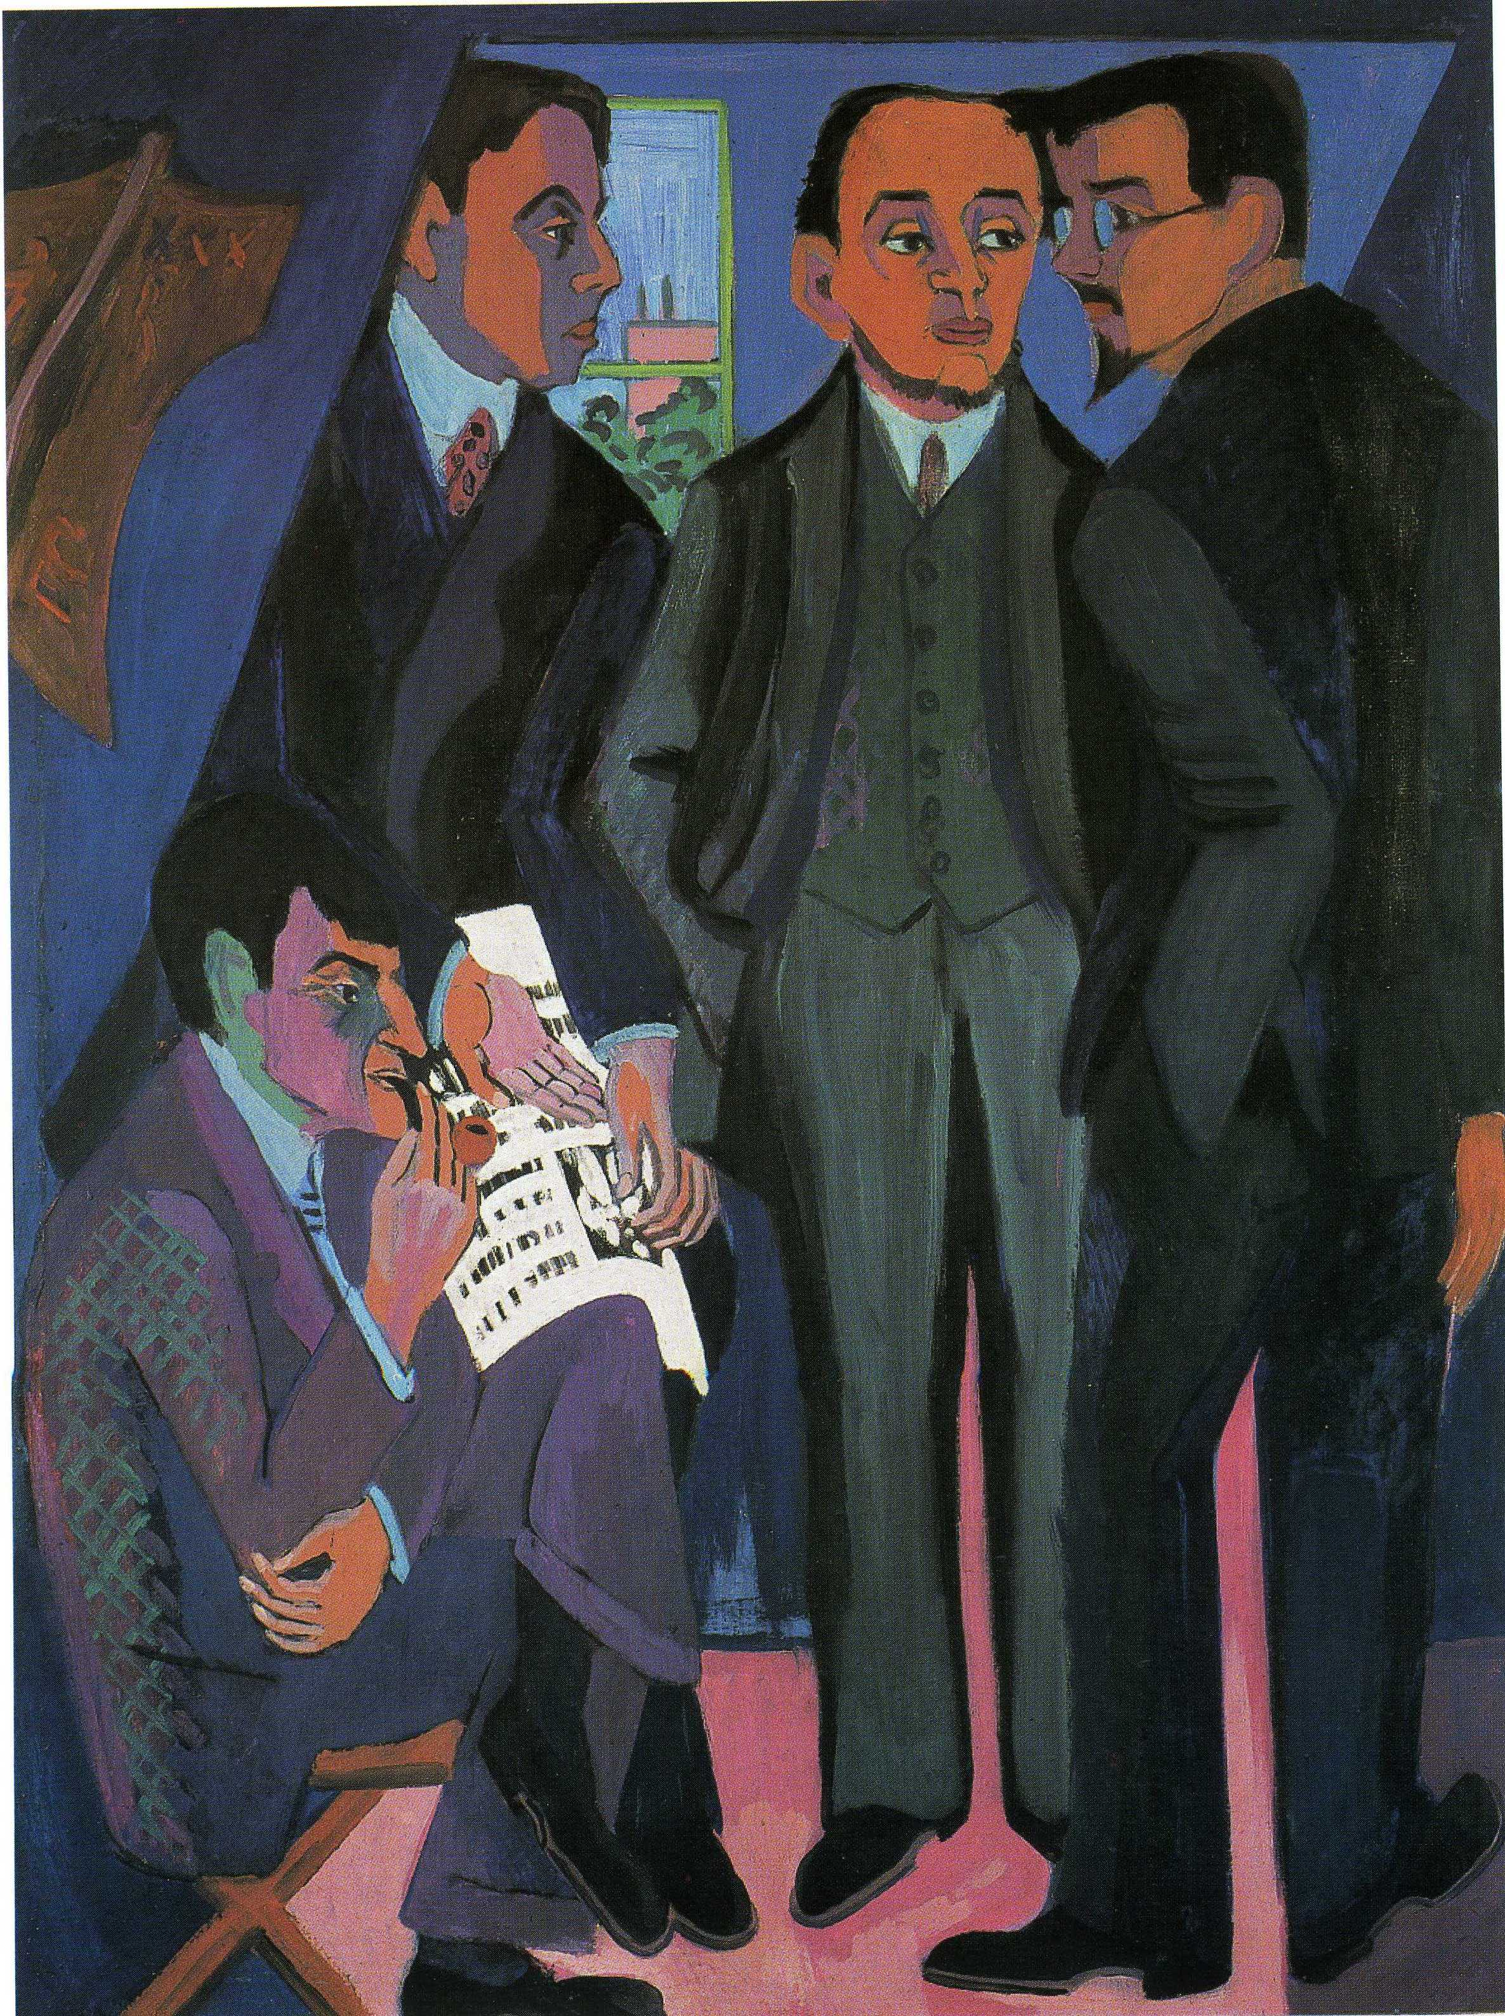


By Souza Pinto, Egareé, Museum of Teixeira Lopes
By Ernst Ludwig Kirchner, Um Grupo de Artistas Otto Mueller, Kirchner, Heckel, Schmidt-Rottluff, 1926-1927

Sex discrimination at work
Less working conditions
Job for life
Less competition
Expertise in one area
Repetitive mechanical work
Fixed timetables

____________________________________________________________________________________________________________________________________________________________________________________________________________________________________________________________________________________________________________________________________
Equal rights for women in the workplace
Better conditions: Life and Medical insurance
Unstable jobs
More competition
Constant job training
Cerebral work
Work overtime (extra hours)
Stress

.

________________________________________________________________________________________________________________________________________________________________________________________________________________________________________________________________________________

more competition
constant job training
less working conditions
better conditions: Life and Medical Insurance
work overtime (extra hours)

repetitive mechanical work
cerebral work
equal rights for women in the workplace
stress
fixed timetables
expertise in one area
sex discrimination at work
less competition
job for life
unstable jobs

Find more in:

